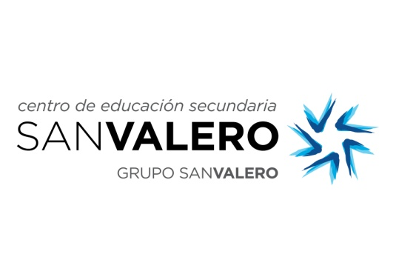



**THANK YOU**

**to**

**… PRIMARY SCHOOL**

**for hosting a Spanish student who completed a week’s**

**Work Experience as part of**

**the Erasmus+ Project “Commuting Across Europe through Work Experience” (CEWE)**

**from the … to the… of March 2015.**

**ERASMUS+ Coordinator in Sheffield**

***Sheffield , March 2015***