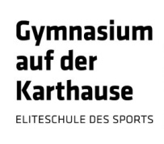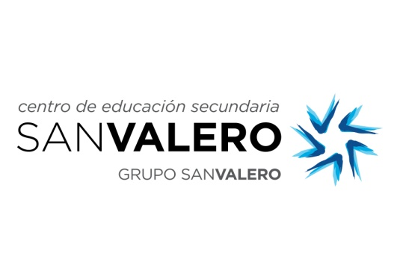



**CERTIFICATE OF ACHIEVEMENT**

**This is to certify that**

**from San Valero School, Zaragoza (Spain)**

**has successfully participated in**

**the Erasmus+ Project “Commuting Europe Across Work Experience” (CEWE)**

**and carried out her work experience at**

**, Sheffield**

**from the to the of March 2015.**

***Sheffield , 27th March 2015***

|  |  |
| --- | --- |
| The Erasmus+ Coordinator in Sheffield | The Headteacher |